Lab Task (Server Side)

Create database named “Shop” and create following 2 tables **user** and **products** in it:





Add some data to these tables.

Now, create a new “dynamic web project” in eclipse, and add a new JSP page named “jsp.index”, now run this project, try to understand this page’s code and its output.

|  |
| --- |
| <%@ page language=*"java"* contentType=*"text/html; charset=ISO-8859-1"*  pageEncoding=*"ISO-8859-1"* import=*"java.sql.*"*%>  <!DOCTYPE html PUBLIC "-//W3C//DTD HTML 4.01 Transitional//EN" "http://www.w3.org/TR/html4/loose.dtd">  <html>  <head>  <meta http-equiv=*"Content-Type"* content=*"text/html; charset=ISO-8859-1"*>  <title>Insert title here</title>  </head>  <body>  <form>  <select name=*"category"* onchange=*"this.form.submit()"*>  <option value=*"--select--"*>--select--</option>  <option value=*"1"*> Mobile</option>  <option value=*"2"*> Books</option>  </select>  <br/>  <select multiple>  <%  String cat=request.getParameter("category");  out.print("cat selecte : " +cat);  **try**  {  Class.forName("com.mysql.jdbc.Driver");  Connection con=DriverManager.getConnection("jdbc:mysql://localhost/test","root","");  Statement st=con.createStatement();  ResultSet rs=st.executeQuery("select * from products where catId="+ cat);  **while**(rs.next())  {  out.print("<option>" + rs.getString(2)+ "</option>");  }  }  **catch**(ClassNotFoundException ex)  {  out.println("class not found");    }  **catch**(Exception e)  {  System.out.println("Exception: " + e.getMessage());  e.getStackTrace();  }  %>  </select>  </form>  </body>  </html> |

**NOTE: For your project, DO NOT write db connectivity code directly in your servlet or jsp page. (Here it is done just to keep at code in one file so that you can understand it easily). Make another class and create your proper db function in that class, then in servlet/JSP just call those function,as done in the example at** (\\printsrv\Teacher Data\Aisha\IP\post mid\29th Jan Lec\Example_DbCon\src\test).

Output of this page is something like:

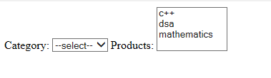

If you change selection in first dropdown, second dropdown will automatically be populated again from database to change products

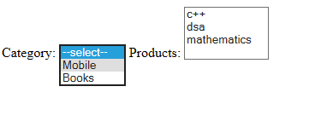

Now, you have to create a login page paste following:

|  |
| --- |
| <!DOCTYPE html>  <html>  <head>  <meta charset=*"ISO-8859-1"*>  <title>Insert title here</title>  </head>  <body>  <form action=*""* method=*"get"*>  User Name: <input type=*"text"* name=*"user"*/> <br/>  Password: <input type=*"password"* name=*"password"*/> <br/>  <input type=*"submit"* value =*"Login"*/>  </form>  </body></html> |

**Create a servlet** that will be called when user clicks login button, and authenticates user matching its credentials from users table.

If user name password is matched, redirect user to the index page, also show welcome username message on index page, otherwise display an error message.

NOTE: We will be covering JSP in next week, however, JSP basic guide is placed at teacher data, in post mid folder if you need it for your db project completion.